## **Removing the word "Apache" from the response header on Ubuntu 22 version**

**Reference:-**

<https://stackoverflow.com/questions/35360516/cant-remove-server-apache-header>

<https://hostadvice.com/how-to/web-hosting/ubuntu/how-to-setup-modsecurity-for-apache-on-ubuntu-18-04/>

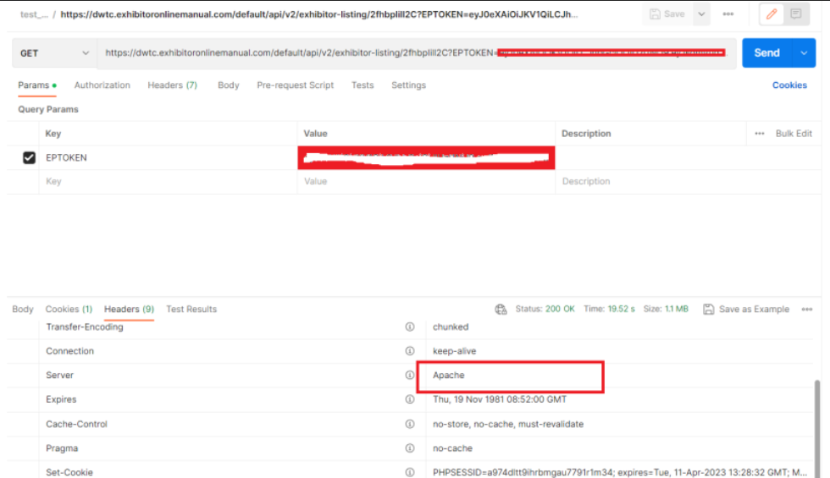

**Pre-requisites:-**

1] Server should have apache2 present [any version]

2] Remove the server from ALB if attach [for the time been]

**Execution steps:-**

Step1:- Login to the server via terminal on which apache name needs to be removed from response headers.

Step2:- check apache2 service using below command.

$ systemctl status apache2.service

Step3:- Install ModSecurity on server.

$ sudo apt-get install libapache2-mod-security2 -y

Or

$ apt-get install libapache2-mod-security2 -y

Note:- Do not restart any service if asked [ubuntu 22 only]

Click on escape if asked for restart

Step4:- Enabling the module and restarting Apache

$ sudo a2enmod security2

$ systemctl restart apache2.service

Step5:- Check that the module is enabled

$ apachectl -M | grep security

OR

$ apache2ctl -M | grep security

Step6:- Take backup of apcahe2.conf file and edit the changes.

$ cp /etc/apache2/apache2.conf /etc/apache2/apache2.conf_original_<date>

Step7:- Add below header in apache2.conf file at end of the file.

$ vim /etc/apache2/apache2.conf

……

# vim: syntax=apache ts=4 sw=4 sts=4 sr noet

<IfModule security2_module>

SecRuleEngine on

ServerTokens Min

SecServerSignature " "

</IfModule>

:wq! [To save the file]

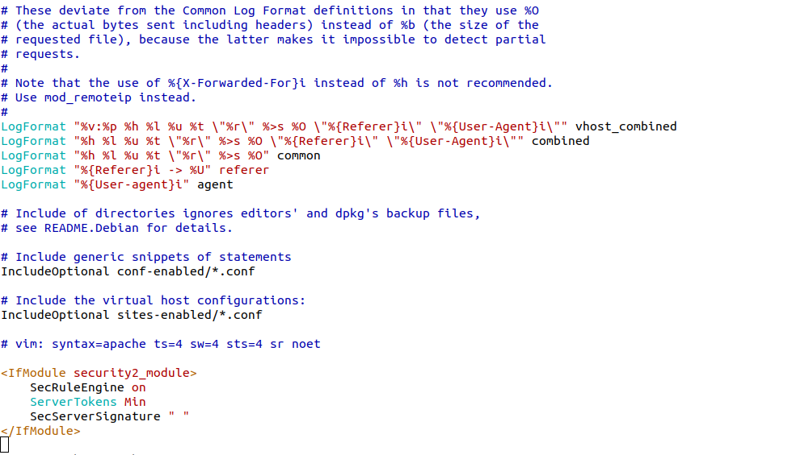

Step 8:- check the configuration file and restart the apache2 service to see the changes.

$ apache2ctl -t

$ systemctl restart apache2.service

$ systemctl status apache2.service

**Testing:-**

**[A] On Terminal:-**

Run the below command to check Apache name gone.

$ curl --head https://<application-URL>

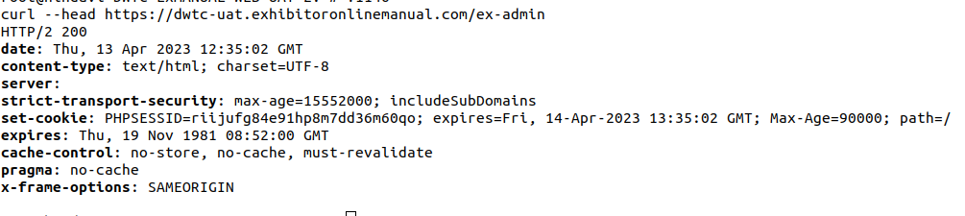

**[B] On browser:-**

Open the application and check in Network headers or use Postman to verify details.

As per the below screenshot you can see the server field is empty.

